

IALA S-201
Product Specification

Edition 2.0.0 – May 2025

IALA AtoN Information Product Specification

Document Revisions
Revisions to the IALA Document are to be noted in the table prior to the issue of a revised document.
Date | Page / Section Revised | Requirement for Revision
03/03/2016 | Various | See comments table 20160127
09/03/2016 | Section 7.6 Geometry | Remove square brackets from S-201
09/03/2016 | Section 8.2 Data Compliance | S-58 replaces Annex H for consistency
09/03/2016 | Section 12.1 Encoding | Indicate conformity with S-100
09/03/2016 | Section 11 Portrayal | Removed (not required)
04/07/2016 | Various | FTA proposals
21/09/2016 | Various | Reviewed at ENAV 19
26/11/2016 | Various | Updated various sections and figures following data model update
31/01/2017 | Various | Changed precision of lat/long, added units, various editorial changes
15/08/2017 | Various | Partial implementation of TG1 July 2017 report. Aligned metadata and dataset identification with S-100 Edition 3.0.0, included AIS AtoNs and base station (Radio Station), minor clarifications for file names and support files.
31/09/2019 | Various | Updating specification to S-100 v4.0.0 and various edits following review at IALA ARM9.
19/03/2022 | Various | Improved application schema, updating specification to S-100 Ed.5.0.0
02/09/2022 | Various | Updated various sections and figures following data model update
28/03/2025 | Various | Updated data model
03/04/2025 | Various | IALA WG2 updated whole document
28/04/2025 | Various | Updating specification to various edits following review at IALA ARM members
19/05/2025 | Various | Updating specification to various edits following review at IALA ARM members

Table of Contents
Contents
1 Overview 7
1.1 Introduction 7
1.2 References 7
1.2.1 Normative references 7
1.2.2 Informative references 7
1.3 Terms, definitions and abbreviations 7
1.3.1 Terms and definitions 7
1.3.2 Acronyms 7
1.4 Product specification metadata 8
1.4.1 IALA Product Specification Maintenance 8
2 Specification Scope 10
3 Data Product Identification 10
4 Data Content and structure 11
4.1 Introduction 11
4.2 Application Schema 11
4.3 Meta features application schema 25
4.4 Feature Catalogue 26
4.5 Feature Types and Feature Instances 27
4.6 Dataset 27
4.7 Dataset rules 27
4.8 Geometry 27
5 Coordinate Reference Systems (CRS) 29
5.1 Introduction 29
5.2 Horizontal Geodetic Datum 29
5.3 Vertical Datum 29
5.4 Units of Measure 29
6 Data Quality 29
6.1 Introduction 29
6.2 Data Compliance and Integrity 29
6.3 Positional accuracy 30
6.4 Lineage 30
7 Data Capture and Classification 30
8 Data Maintenance 31
8.1 Introduction 31
8.2 Maintenance and Update Frequency 31
9 Portrayal 32
10 Data Product format (encoding) 32
10.1 Introduction 32
10.2 Encoding of Latitude and Longitude 32
10.3 Encoding of coordinates as decimals 32
10.4 Numeric Attribute Encoding 32
10.5 Text Attribute Values 33
10.6 Mandatory Attribute Values 33
10.7 Unknown Attribute Values 33
10.8 Structure of dataset files 33
10.9 Object identifiers 34
10.10 Dataset validation 34
10.11 Data coverage 34
10.12 Data overlap 34
10.13 Data quality 34
10.14 Data extent 34
11 Data Product Delivery 34
11.1 Exchange set 35
11.2 Datasets 36
11.3 Dataset size 37
11.4 Dataset file naming 37
11.5 Cancellations 37
11.6 Support Files 37
11.7 Support File Naming 38
11.8 Support file management 38
11.9 Exchange Catalogue 38
12 Metadata 39
12.1 Introduction 39
12.2 Metadata classes 39
12.2.1 S100_ExchangeCatalogue 39

Overview

Introduction
The Aids to Navigation (AtoN) Information Product Specification provides a common structure for the exchange of information about AtoNs including metadata like maintenance schedules, equipment type such as battery and bulb types. This includes buoys, beacons, racons, lights, sound signals and AIS. The product contains the positions, properties, operational status and general comments related to an AtoN.
The Product Specification can be used to exchange AtoN information in a consistent form between Lighthouse Authorities, Hydrographic Offices and other organisations to include commercial and professional agencies. S-201 is not intended to be for navigation systems like ECDIS, and therefore is not constrained by ECDIS requirements. This means that S-201 can include additional information to inform about AtoN services that would not be appropriate in a navigation system, such as AtoN fixing method, moorings and power source.

References

Normative references
IHO S-100 IHO Universal Hydrographic Data Model, Edition 5.2.0, June 2024
ISO 8601:2004 Data elements and interchange formats _ Information interchange _ Representation of dates and times
ISO/TS 19103:2005 Geographic information - Conceptual schema language
ISO 19111:2003 Geographic information - Spatial referencing by coordinates
ISO 19115-1:2014 Geographic information – Metadata (Tech Corr. 1, 2006)
ISO 19131:2007 Geographic information - Data product specifications
ISO/IEC 19505-1:2012, Information technology — Open Distributed Processing - Unified Modelling Language Version 2.4.1
ISO 3166-1 Country Codes

Informative references
ISO, 2006. ISO 19109 Geographic Information - Rules for Application Schema.
ISO, 2007. ISO 19135 Geographic Information – Procedures for Item Registration.
ISO, 2009. ISO 19136 Geographic Information - Geography Markup Language (GML).
IMO, 2008. Safety of Navigation Circular SN/Circ.243
IALA, 2012. Guideline 1088 on an Introduction to Preparing S-100 Product Specifications

Terms, definitions and abbreviations

Terms and definitions
Terms and definitions have been taken from the normative references cited in clause 1.2.1.

Acronyms
ASCII American Standard Code for Information Interchange
AtoN Aids to Navigation
CRS Coordinate Reference System
ECDIS Electronic Chart Display and Information System
EPSG European Petroleum Survey Group
ENC Electronic Navigational Chart
GML Geography Markup Language
HTML Hypertext Markup Language
IALA International Organization for Marine Aids to Navigation
IHO International Hydrographic Organization
IMO International Maritime Organization
ISO International Organization for Standardization
TIFF Tag Image File Format
XML Extensible Markup Language
XSD XML Schema Definition
XSLT eXtensible Stylesheet Language

Product specification metadata

Title | Aids to Navigation Product Specification
Version  Identifier | 2.0.0  S-201
S-100 version | 5.2.0
Date | 19 May 2025
Language | English
Classification: | 001 - unclassified
Contact: | IALA  10, rue des Gaudines  78100 Saint Germain en Laye, France  Telephone: +33 1 34 51 70 01 Fax: +33 1 34 51 82 05
URL: | www.iala.int
Maintenance: | The product specification is maintained by IALA and amendments are performed on a needs base, up to maximum of one new release per calendar year.

IALA Product Specification Maintenance
This section details the process of maintaining this document.

Introduction
Changes to this product specification will be released by IALA as a new edition, revision, or clarification.

New Edition
New editions of this product specification introduce significant changes. New editions enable new concepts, such as the ability to support new functions or applications, or the introduction of new constructs or data types.

Revisions
Revisions are defined as substantive semantic changes to a product specification. Typically, revisions will change a product specification to correct factual errors; introduce necessary changes that have become evident as a result of practical experience or changing circumstances. A revision must not be classified as a clarification. Revisions could have an impact on either existing users or future users of a product specification. All cumulative clarifications must be included with the release of approved corrections.
Changes in a revision are minor and ensure backward compatibility with the previous versions within the same edition. Newer revisions, for example, introduce new features and attributes. Within the same edition, a data product of one version could always be processed with a later version of the feature and portrayal catalogues.

Clarification
Clarifications are non-substantive changes to this product specification. Typically, clarifications: remove ambiguity; correct grammatical and spelling errors; amend or update cross references; insert improved graphics, spelling, punctuation and grammar. A clarification must not cause any substantive semantic change to a product specification.
Changes in a clarification are minor and ensure backward compatibility with the previous versions within the same edition. Within the same edition, a data product of one clarification version could always be processed with a later version of the feature and portrayal catalogues, and a portrayal catalogue can always rely on earlier versions of the feature catalogues.

Version Numbers
The associated version control numbering to identify changes (n) to this product specification will be as follows:
New editions denoted as n.0.0
Revisions denoted as n.n.0
Clarifications denoted as n.n.n

Specification Scope
This product specification describes one data product and therefore requires only one scope which is described below:

Scope ID: Aids to Navigation Information datasets

Hierarchical level: MD_ScopeCode - 005

Hierarchical level name: dataset

Level description: Information applies to the dataset

Extent: EX_Extent.description: Global coverage of maritime areas

Data Product Identification
This clause describes how to identify data sets that conform to the specification. A dataset that conforms to this Product Specification may be identified by its discovery metadata as defined in clause 13 of this specification. The information identifying the data product may include the following items from S-100 5.2.0 clause 11-6 (adapted from ISO 19115-1).

Title | Aids to Navigation (AtoN) Information
Alternate Title | AtoN Information
Abstract | An Aids to Navigation Information product is a vector dataset containing information regarding the aids to navigation within a defined geographical area.
Topic Category | Environment, Oceans, Structure and Transportation
Geographic Description | CharacterString
Spatial Extent | Global
Description | Aids to Navigation information, such as characteristics of the AtoN, its location and maintenance procedures that apply.
Spatial Resolution | All scales
Purpose | Aids to Navigation Information datasets are produced to allow the exchange of AtoN information with interested stakeholders.
Language | English
Spatial Representation Type | Vector
Point of Contact | IALA

Data Content and structure

Introduction
An AtoN Information dataset is a feature-based product. The following sub-sections contain the product application schema expressed in UML and an associated feature catalogue. The feature catalogue provides a full description of each feature type including its attributes and attribute values in the data product.

Application Schema
The application schema conforms to the modelling conventions of UML as constrained in S-100 Part 1 and conforms to the General Feature Model described in S-100 Part 3.
An overview of the application schema is provided in Figure 1. Figures 2 - 9 provide details for feature types and their relationships. The allowed values for enumeration attributes are depicted in Figures 10 - 14. In conformance to S-57 and S-101, aids to navigation are described by combinations of structure and equipment features.
- The feature type AidsToNavigation is an abstract type from which the geographic feature types for aids to navigation are ultimately derived.
- StructureObject and Equipment are abstract types which collect the attributes and relationships common to structure and equipment features respectively. The relationship that exists between them is between structure and equipment features in the combining of structure and equipment object(s) to make up an individual aid to navigation.
- GenericBeacon and GenericBuoy are abstract types which collect attributes common to multiple types of beacon and buoy features respectively.
- Links to the geographic features for individual AtoN constituting the collection object are modelled by feature associations (the “Aggregations” and “Associations” links between Aggregation and Association classes and the common supertype for geographic AtoN features (AidsToNavigation)). The type of the collection feature is indicated by the attribute categoryOfAggregation which can take the allowed values listed in the codelists of the same names.
- Structure-equipment associations are modelled by the association labelled StructureEquipment, between classes Structure and Equipment in Figure 1.
- Features participating in the same range system are indicated by the association labelled RangeSystem, between feature classes NavigationLine and RecommendedTrack.
- The model supports three types of AIS features like PhysicalAISAidToNavigation, VirtualAISAidToNavigation, SyntheticAISAidToNavigation. The AIS feature inherits attribute types from the super abstract class ElectronicAton and is used as an independent Aton that is not as equipment or structure. The AIS features are associated with the RadioStation having the attribute values of AIS Base Station, which broadcasts it. AIS related items are shown in Figure 4.
- Structure features include Lighthouse, Landmark, Pile, LightFloat, OffShorePlatform, LightVessel, and SiloTank features as well as buoys and beacons of different kinds. The detailed models of structure features are depicted in Figure 2.
- The equipment objects are Daymark, FogSignal, RadarReflector, Light, Retroreflector, Topmark, RadarTransponderBeacon, EnvironmentalObservationEquipment, PhysicalAISAidToNavigation, and RadioStation. Daymark is allowed to act as either a structure or equipment feature in practice, but this cannot at present be modelled in the application schema since S-100 discourages multiple inheritance. The detailed model of equipment objects is depicted in Figure 3.
- The feature classes Navigation Line and Recommended Track are neither structure nor equipment objects and are depicted in complete detail in Figure 1.
- PowerSource inherited from the Equipment includes information about the type (battery, generator, solar panel, electronical service), status, and manufacturer of the power source.
- MooringWarpingFacility and EmergencyWreckMarkingBuoy are included to support purposes of mooring and emergency wreck buoy.
- CounterWeight, MooringShackle, Bridle, Swivel, CableSubmarine, and SinkerAnchor are defined to define AtoN fixing method, moorings.
- AtonStatusInformation has changeDetails as a complex attribute and changeTypes as enumeration, including advanced notice of changes, discrepancy, proposed changes and temporary changes.
- changeDetails is defined to describe type of AtoN change and the detailed model is depicted in Figure 10.

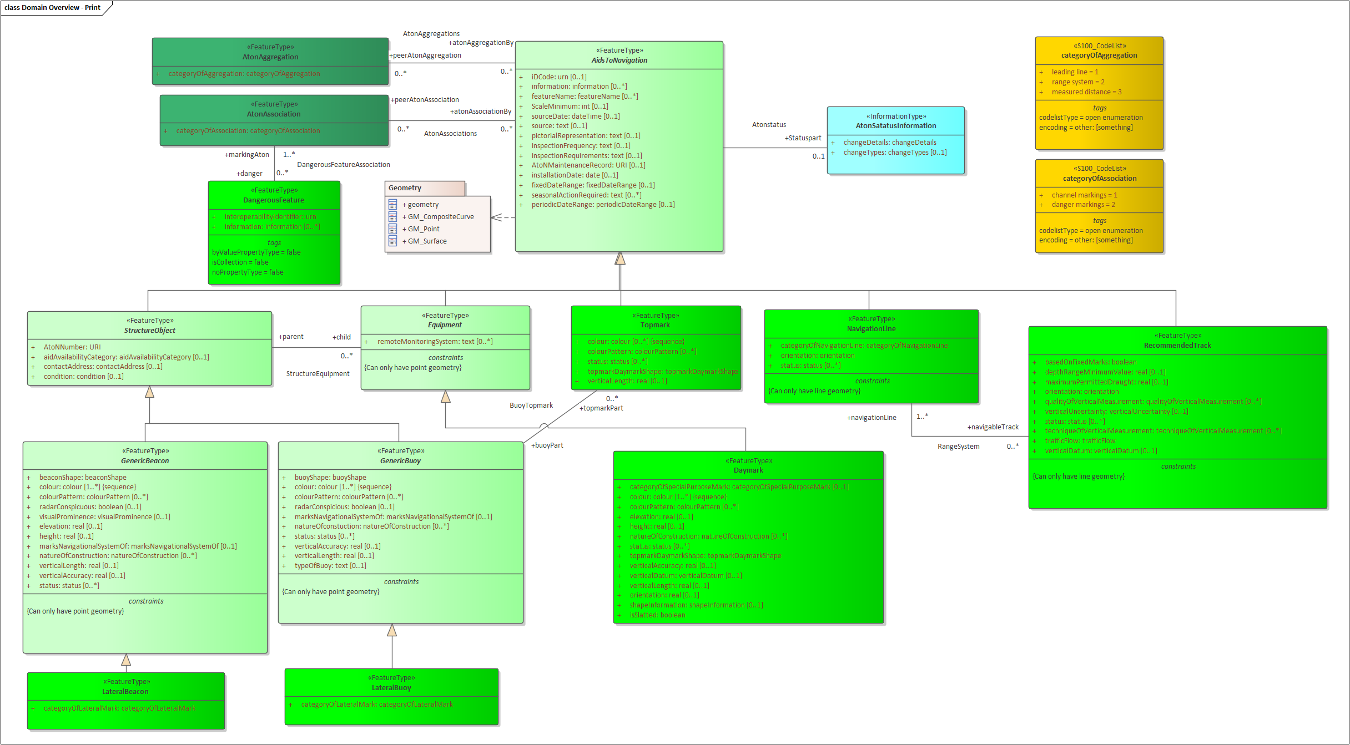
Figure 1. Overview of Application Schema

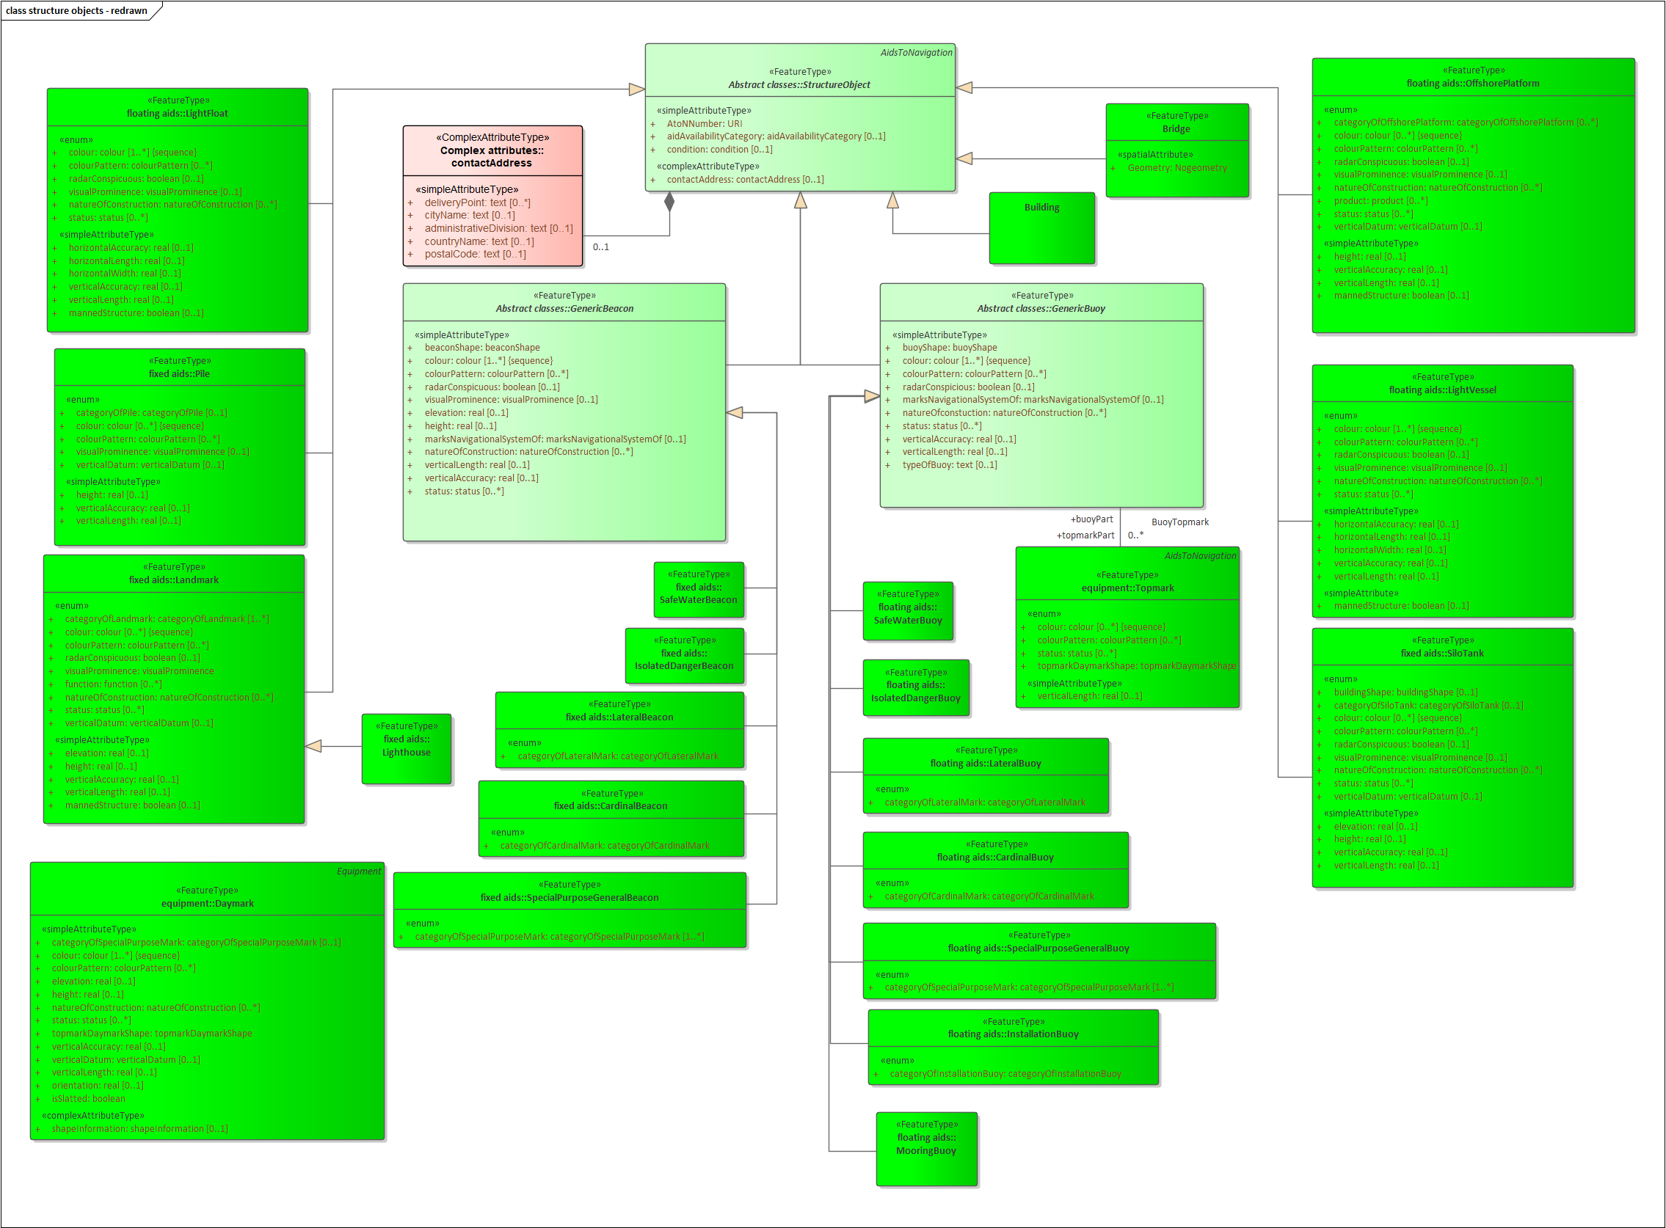
Figure 2. Structure Feature types

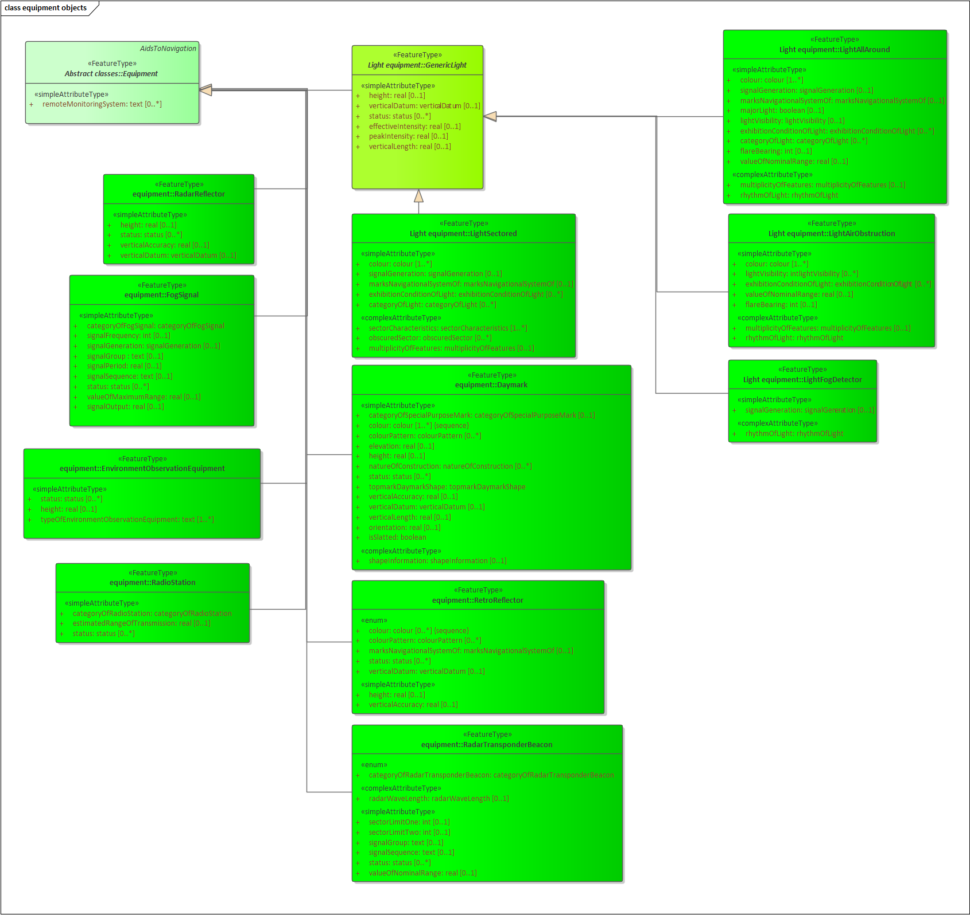
Figure 3. Equipment Feature types
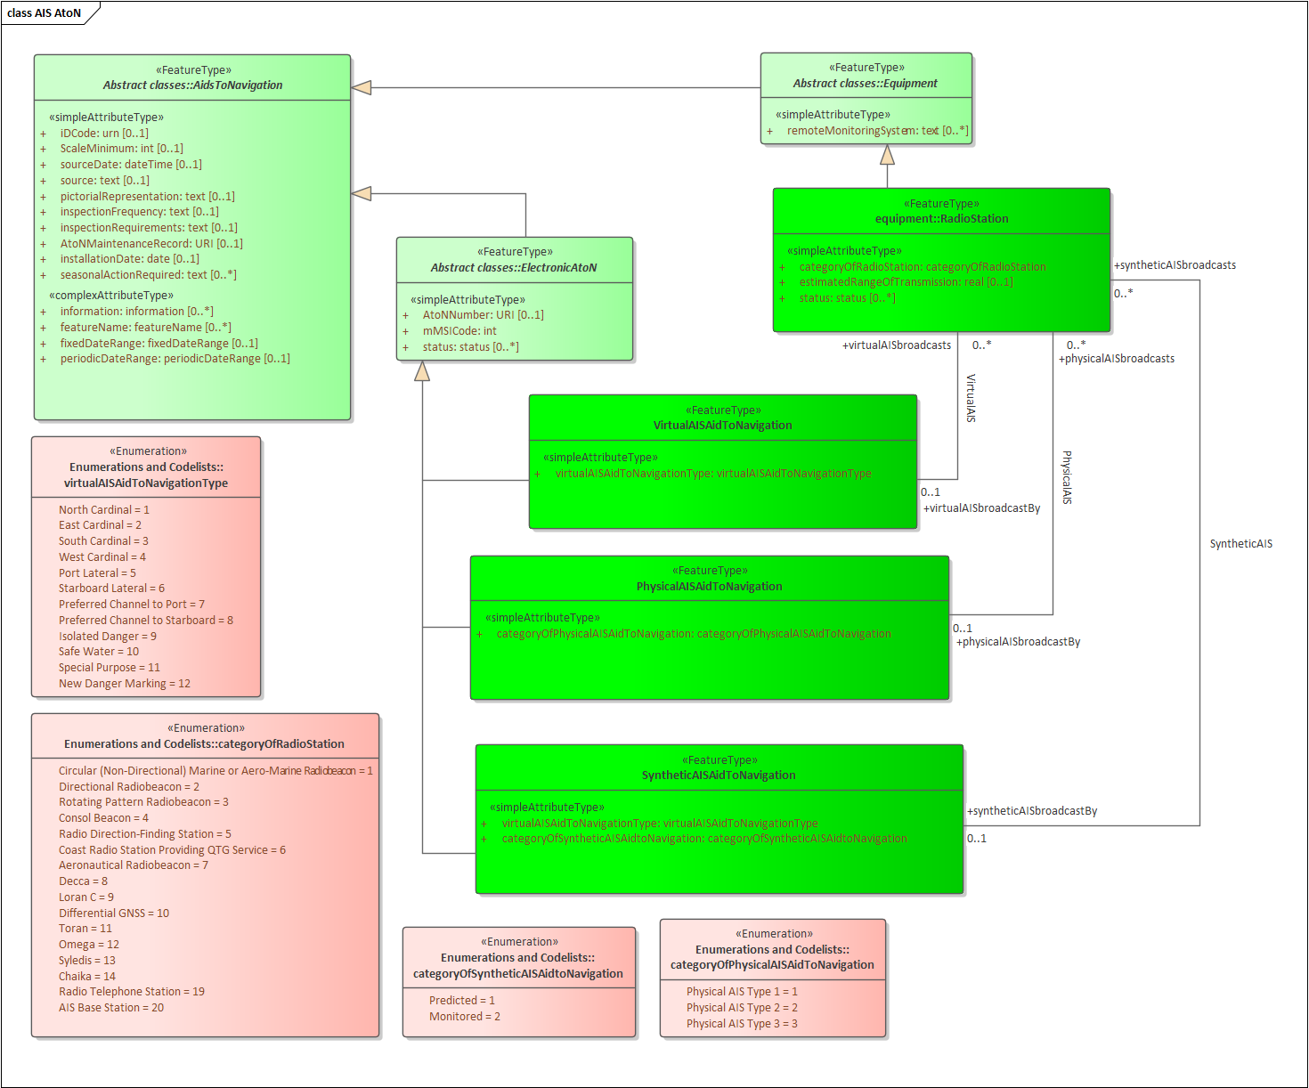
Figure 4. AIS Aids to Navigation
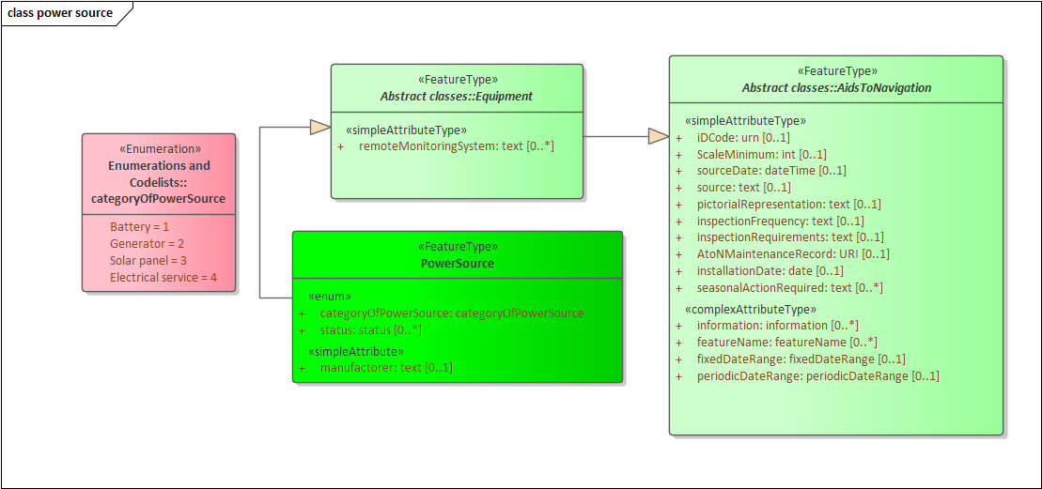
Figure 5. Power source

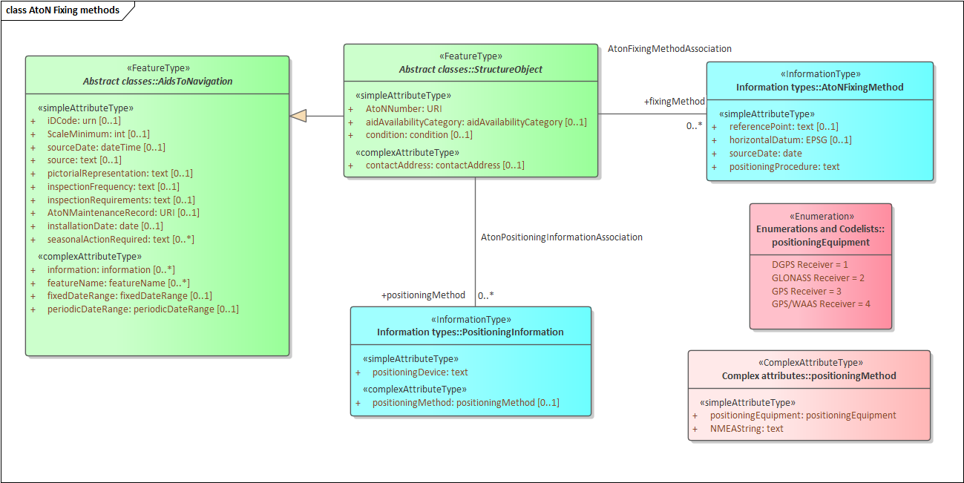
Figure 6. AtoN fixing methods

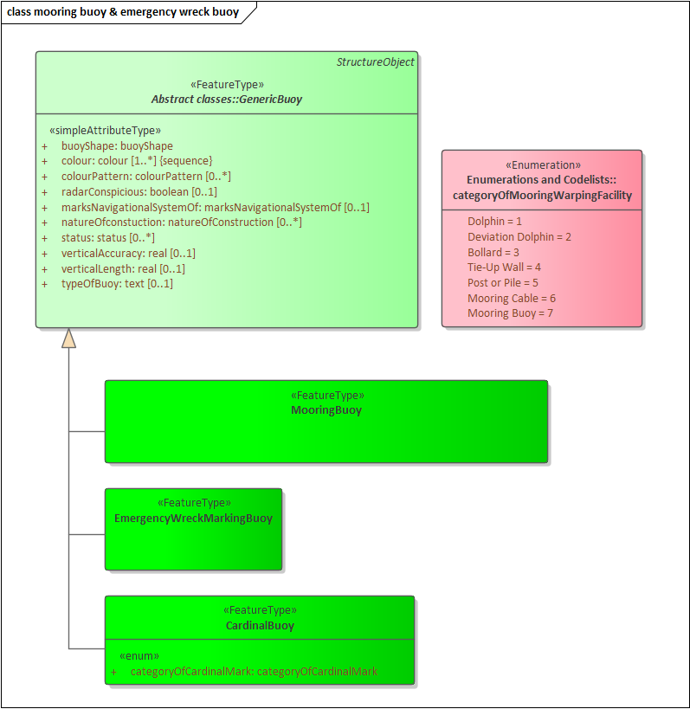
Figure 7. Mooring buoy & emergency wreck buoy
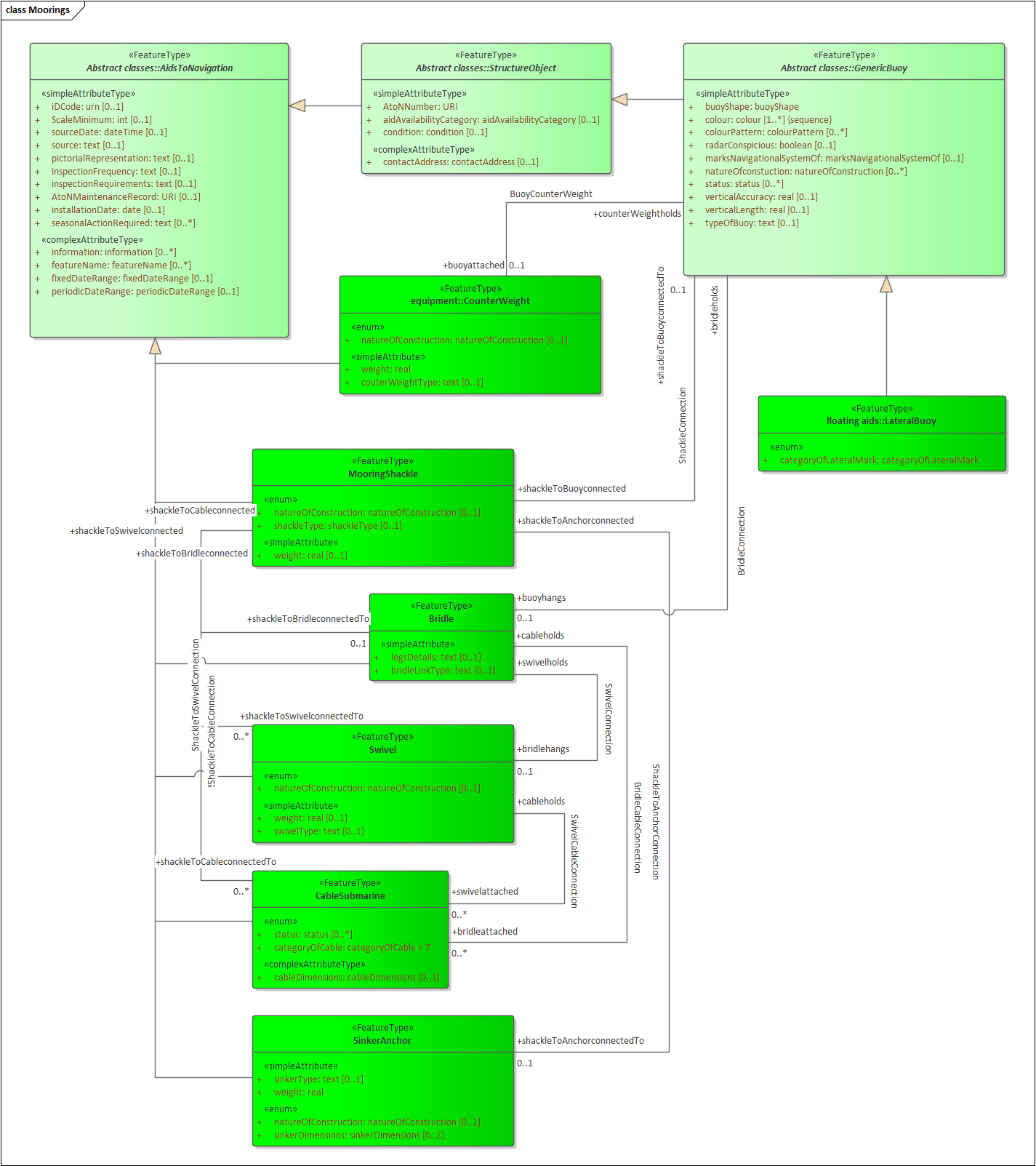
Figure 8. Moorings

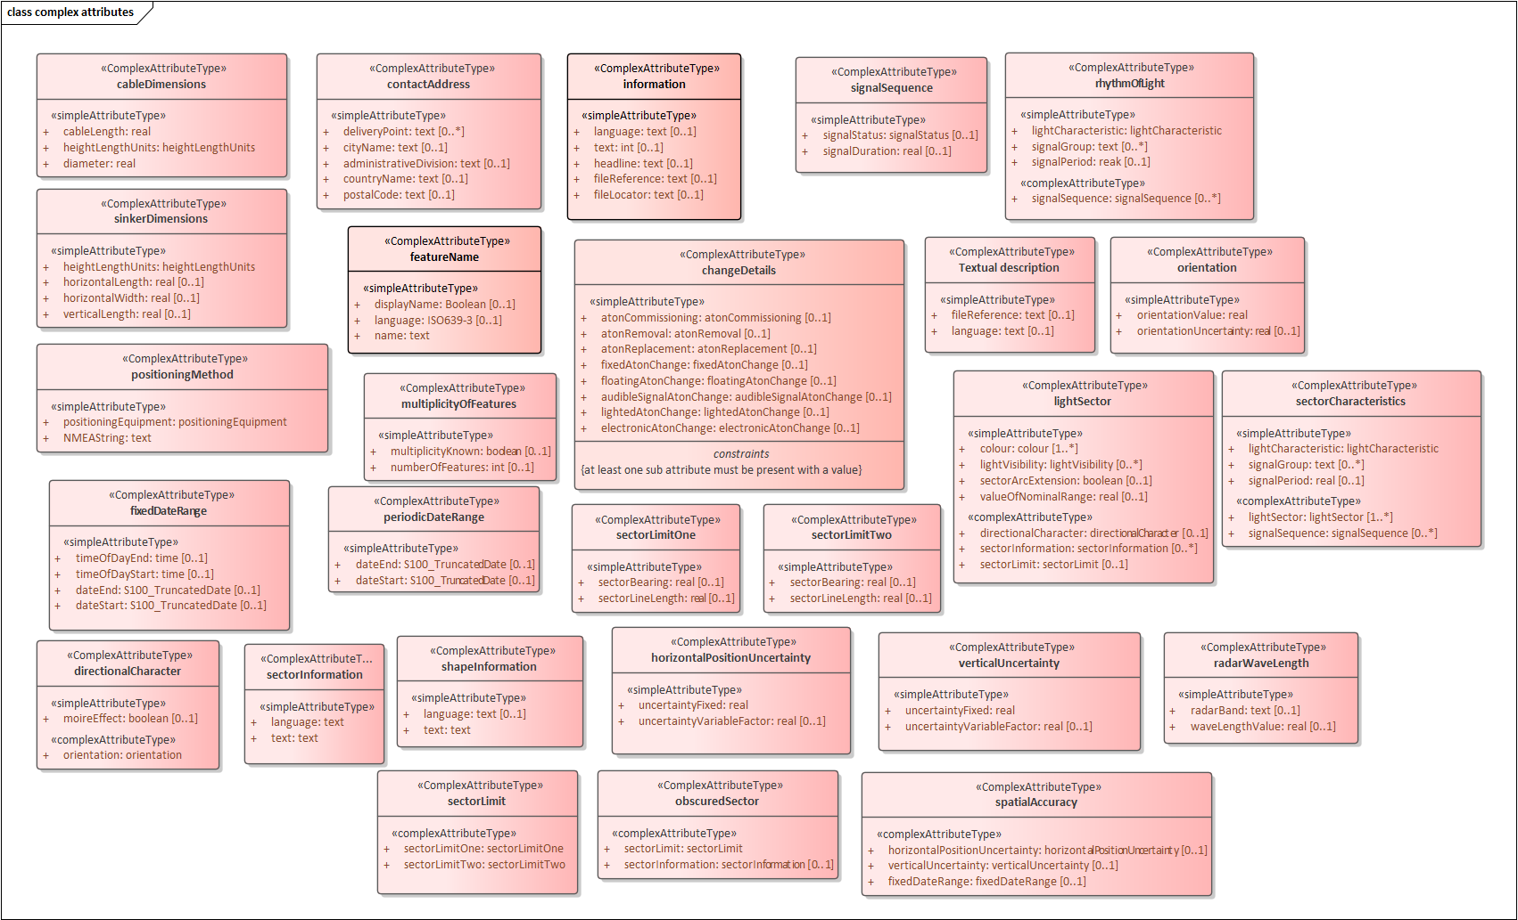
Figure 9. Complex attributes
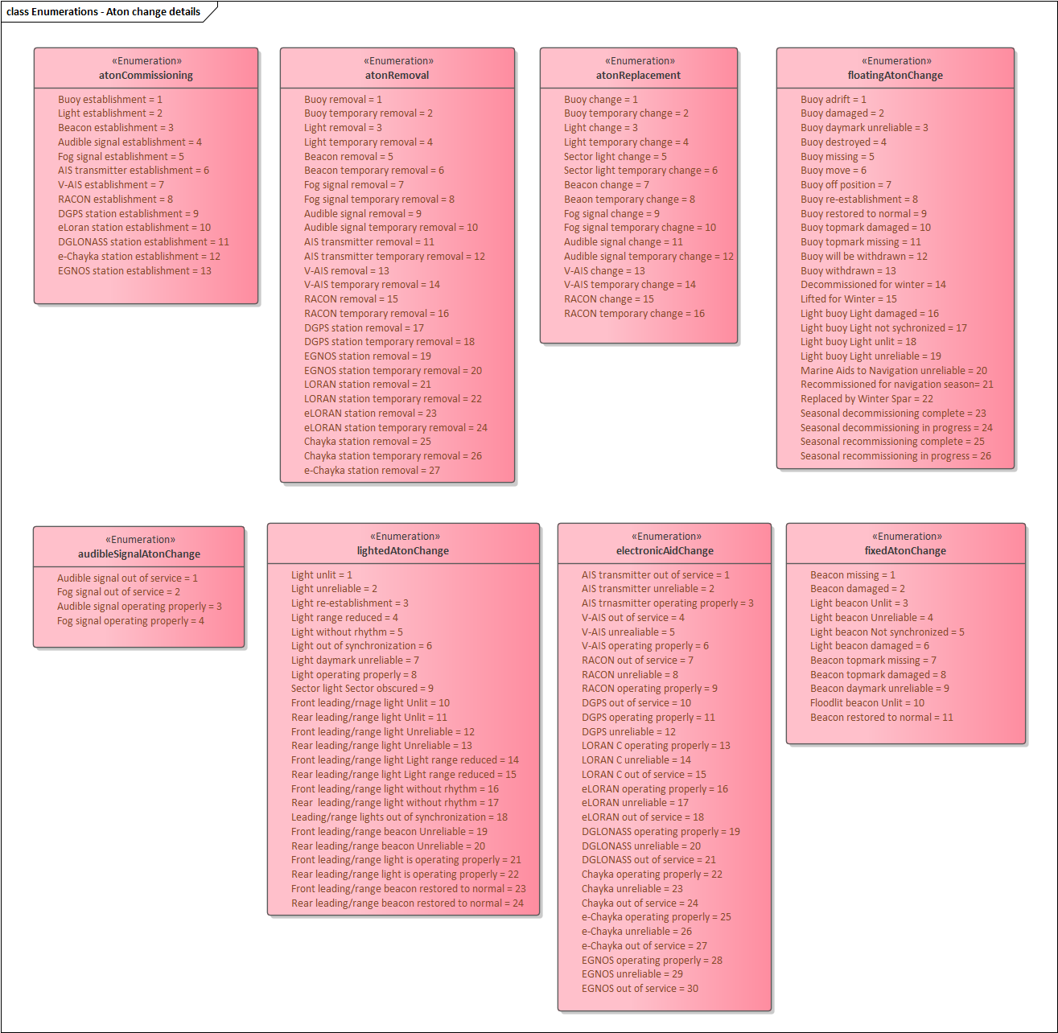
Figure 10. Enumerations – Aton change details
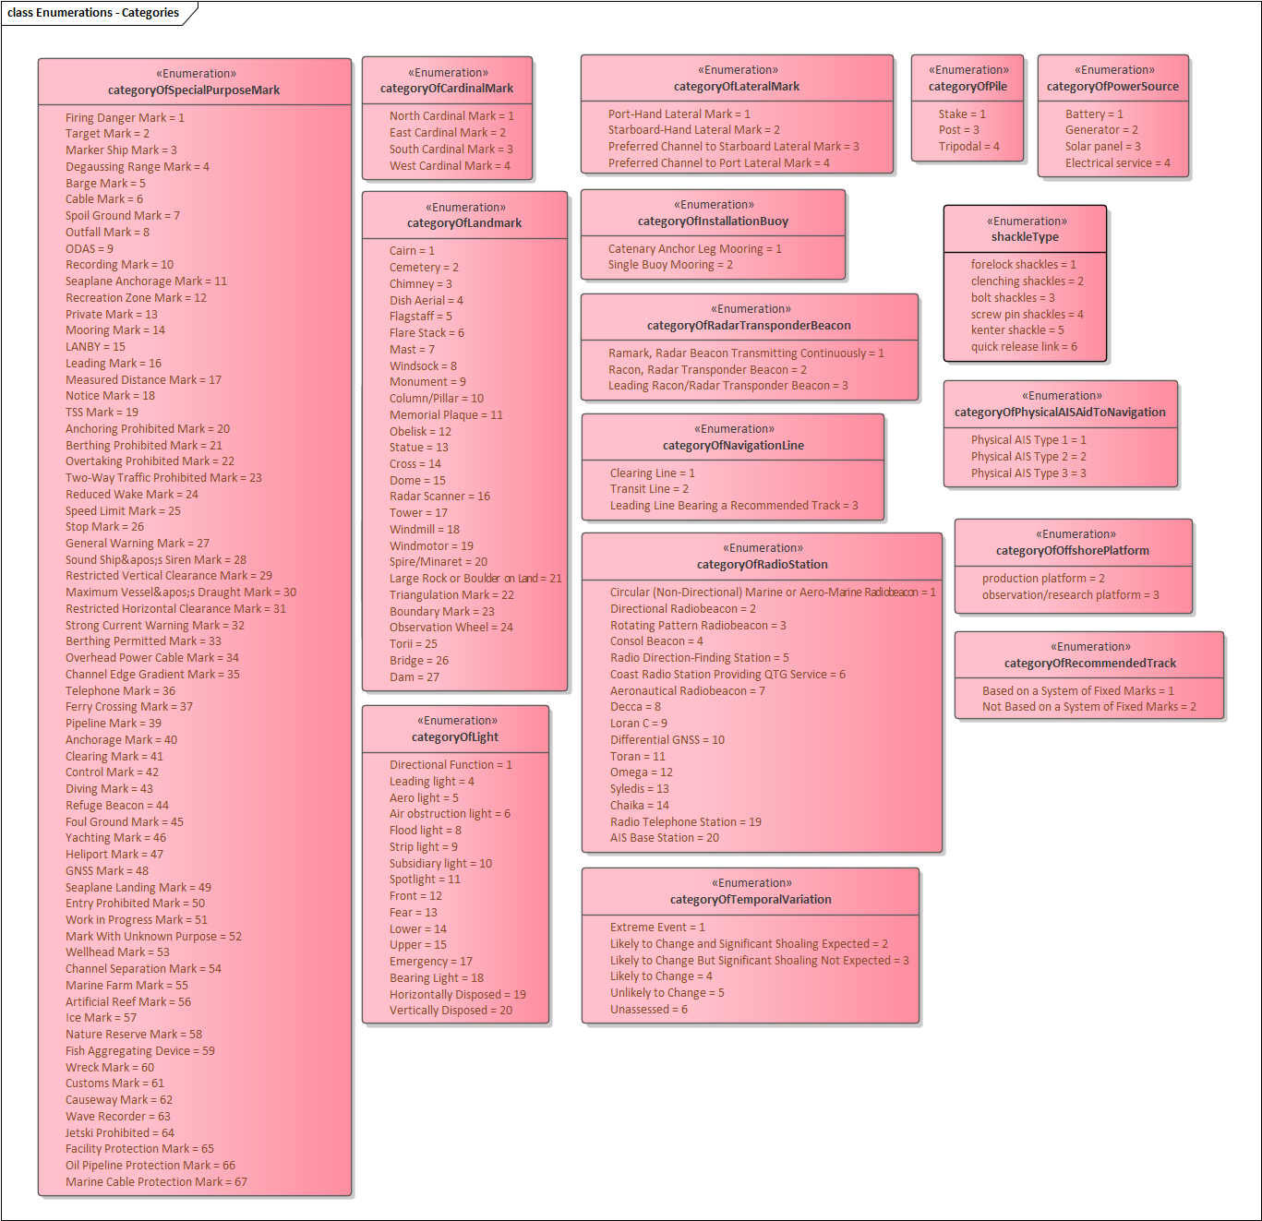
Figure 11. Enumerations – Categories
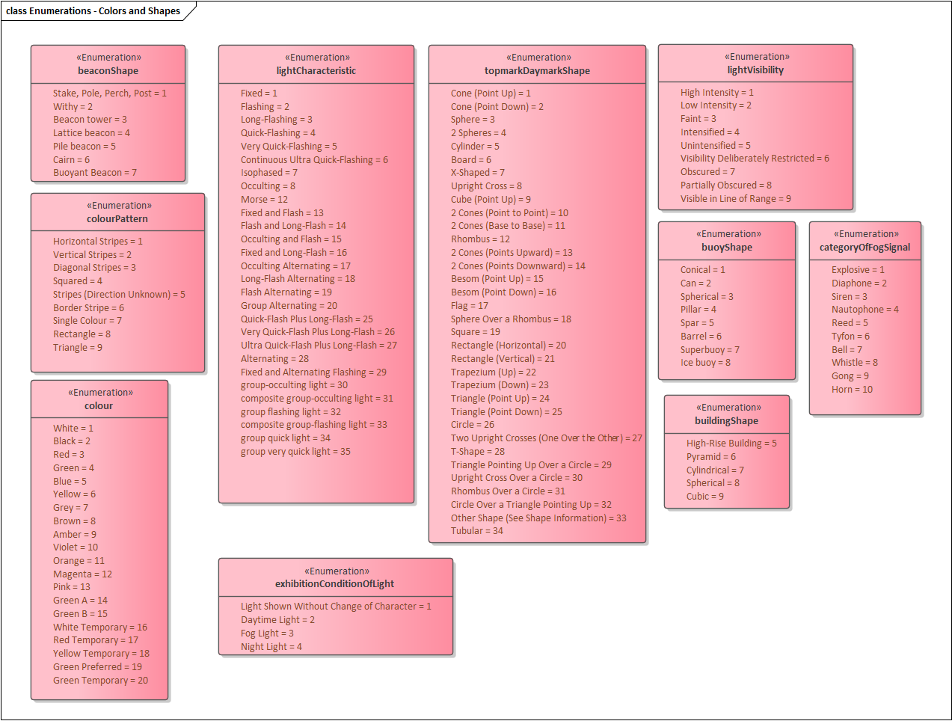
Figure 12. Enumerations – Colour, characteristics, and shape enumerated attributes
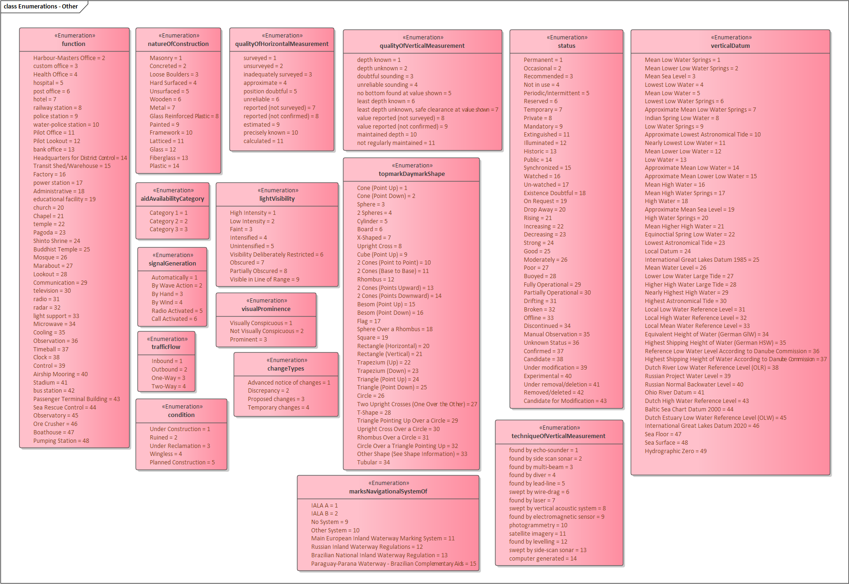
Figure 13. Enumerations - Other enumerated attributes
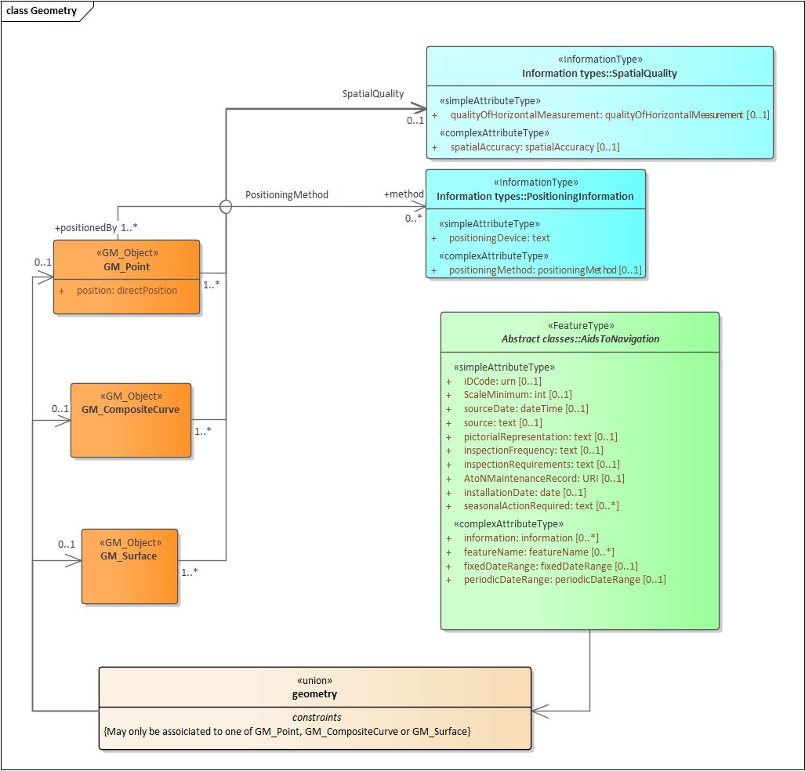
Figure 14. Spatial Attributes

Meta features application schema
Meta features include data coverage, data quality, datums and areas with established characteristics for navigational systems of marks (buoyage direction and system of marks). The application schema for meta features is depicted in Figure 15.
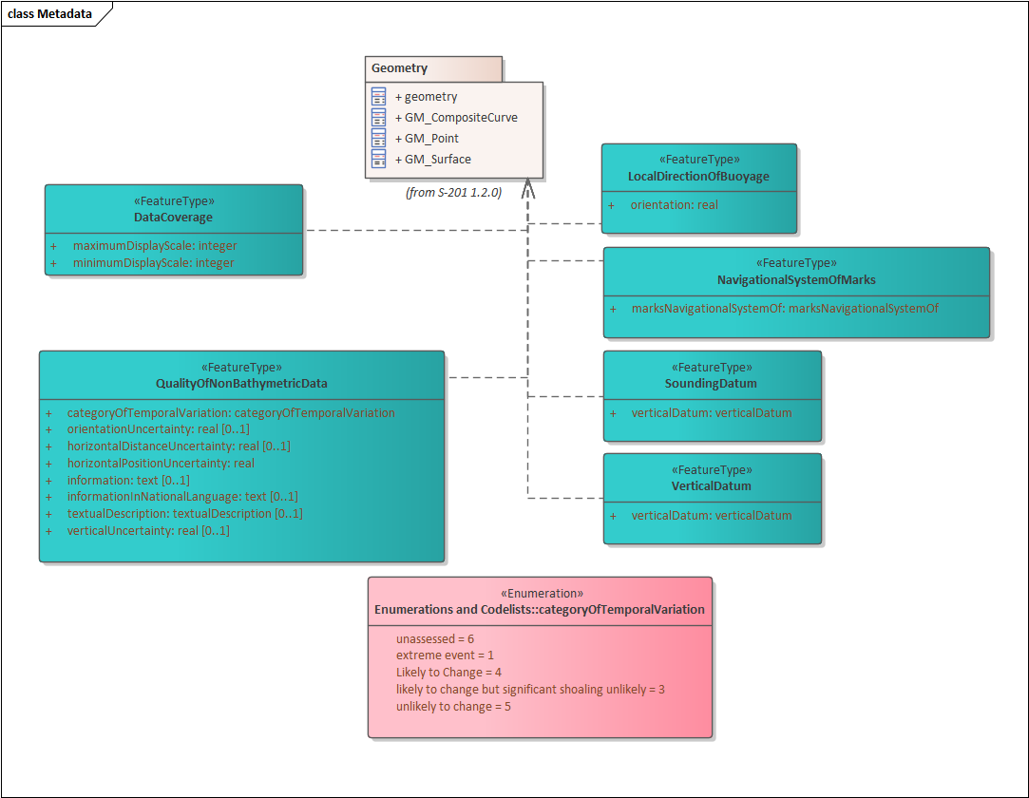
Figure 15. Meta features application schema

Feature Catalogue
The Feature Catalogue describes the feature types, information types, attributes, attribute values, associations and roles which may be used in the product. It also assigns the geometric primitives. The S-201 Feature Catalogue is available in an XML document which conforms to the S-100 XML Feature Catalogue Schema and can be downloaded from the IALA website (iala.int). The feature catalogue is provided in Annex C2.
Name: Aids to Navigation Information Feature Catalogue
Scope: Ocean, Coastal, Ports, Harbours and Inland waters
Version Number: 2.0.0
Version Date: 2025-05-19
Producer: IALA
10, rue des Gaudines
78100 Saint Germain en Laye, France
Telephone: +33 1 34 51 70 01, Fax: +33 1 34 51 82 05
URL : https://www.iala.int
Language: English

Feature Types and Feature Instances
Features have two aspects – feature type and feature instance. A feature type is a class and is defined in a Feature Catalogue. Feature types contain descriptive attributes and do not contain any geometry (i.e. information about the shape and position of a real-world entity). A feature instance is a single occurrence of the feature type and represented as an object in a dataset. A feature instance is located by a relationship to one or more spatial instances. A feature instance may exist without referencing a spatial instance.
S-201 makes use of the following feature types:
Geographic (Geo) feature type – carries the descriptive characteristics of a real-world entity.
Relationship feature type – a feature relationship links instances of one feature type with instances of the same or a different feature type.
Meta features – meta features contain information about other features within a dataset. Information defined by meta features overrides the default metadata values defined by the dataset descriptive records. Meta attribution on individual features overrides attribution on meta features.

Dataset
A dataset is a grouping of features, attributes, geometry and metadata which comprises a specific coverage. AtoN data is scale independent but may use the scaleMinimum and scaleMaximum attributes of S100_GF_SpatialAttributeType to declutter the data in certain viewing scales. The use of scaleMinimum and scaleMaximum is at the discretion of the data producer.

Dataset rules
In order to facilitate the efficient processing and cataloguing of AtoN data the geographic coverage may be split into multiple datasets. There must be no overlapping datasets, except at the agreed adjoining national data limits, where, if it is difficult to achieve a perfect join, a 5 metre overlapping buffer zone may be used; and for this situation, there must be no gaps in data. The discovery metadata of a dataset must list all the DataCoverage features contained within that dataset.
Datasets are replaced by new editions that must be considered a whole replacement of the previous version. Delta change datasets are not permitted.
Datasets should not exceed 50MB.

Geometry
The specifications for S-201 geometry are the same as for S-101 geometry except that 3 dimensional geometry is not permitted even for sounding features, since these features are not part of the S-201 application schema. The relevant (modified) extract from the S-101 product specification is reproduced below.
The underlying geometry of an S-201 dataset is constrained to level 3a which supports 0, 1 and 2 dimensional features (points, curves and surfaces) as defined by S-100 Part 7 – Spatial Schema.
Level 3a is described by the following constraints:
- Each curve must reference a start and end point (they may be the same).
- Curves must not self-intersect.
- The outer boundary of a surface must be in a clockwise direction (surface to the right of the curve) and the curve orientation positive. The inner boundary of a surface must be in a counter-clockwise direction (surface to the right of the curve) and the curve orientation negative.

S-201 further constrains Level 3a with the following:
- Coincident linear geometry must be avoided when there is a dependency between features.
- The interpolation of GM_CurveSegment must be loxodromic.
- Linear geometry is defined by curves which are made of curve segments. Each curve segment contains the geographic coordinates as control points and defines an interpolation method between them. The distance between two consecutive control points must not exceed 0.3 mm at a display scale of 1:10000.

The following exception applies to S-201:
- The use of coordinates is restricted to 2 dimensions.
- Soundings features which use GM_Point or GM_Multipoint with 3 dimensional coordinates are not currently included in S-201.

Coordinate Reference Systems (CRS)

Introduction
The single coordinate reference system is separated into the horizontal and vertical components.

Horizontal Geodetic Datum
WGS84 (World Geodetic System of 1984) must be used for the horizontal reference system for spatial data.

Vertical Datum
Vertical datum shall be selected from the list in verticalDatum enumeration. If the local datum value is used, additional information must be provided using the comment attribute in the metadata, or information attribute on the feature instance. Positive value is above vertical datum and negative is below vertical datum.

Units of Measure
Units of measure for S-201 datasets must be as follows:

For height, depth and vertical length it must be metres.
For range it must be nautical miles.
For orientation it must be degrees.
For signal duration it must be seconds.
For audible signal output it must be decibel.
For signal frequency it must be Hertz.
For intensity of light it must be candela.

Data Quality

Introduction
Data Quality is considered to be meta information and for S-201 it is divided into three parts:
- Data Compliance and integrity
- Positional accuracy
- Lineage

Data Compliance and Integrity
S-201 datasets must be validated using the conformance checks that are listed in S-158:100. The data quality elements listed in S-100 Part 4C that are applicable to S-201 are indicated in the table of conformance checks listed in S-158:100.

Datasets must not be published unless they pass all the compliance checks designated as “Critical”.

The detailed results of applying compliance checks listed in S-158:100 are not required to be reported as part of the exchange set. They may be conveyed as support files or by separate arrangement.

S-201 product specification follows the Category 3 in the S-100 compliancy categories considering the followings
- The Product Specification contains an object model which is available as a Feature Catalogue from the IHO S-100 GI Registry and is compliant with the S-100 spatial model
- The Product Specification adheres to the minimum requirements of S-100 Part 11. The Product Specification specifies which of the S-100 Part 10 encoding methods is used. Metadata is according to S-100 Part 4, a profile of Part 4 or an extension according to Part 4 rules.
- The Product Specification uses only an encoding method defined in S-100 Part 10.

Positional accuracy
S-201 positional accuracy data quality indicators do not use the model of data quality elements defined in S-100 Part 4c.

However, positional accuracy must be evaluated and must be indicated in dataset metadata or spatial attribute metadata as provided in the application schema. This specification does not prescribe a specific required level of positional accuracy.

Lineage
Lineage and process step information elements are not required to be present in S-201 datasets distributed to end user. They may be included as extra metadata in exchange sets distributed to vendors and distributors.

Required source information about S-201 datasets is limited to the source and distribution information contained in discovery metadata described in S-100 Part 4a and Section 12 of this product specification.

Data Capture and Classification
The Data Capture and Classification Guide (DCEG) is found in Annex A.

Data Maintenance

Introduction
Datasets are replaced by new editions that must be considered a whole replacement of the previous version. Delta change datasets are not permitted. Updates and Reissues are not used in S-201. Each edition of a dataset shall have an edition number that is greater than the previous version by one. First edition of a dataset shall have edition number set to 1.

Maintenance and Update Frequency
Datasets are maintained as needed in accordance with data producer policy.

Portrayal
The Portrayal catalogue is found in Annex D.

Data Product format (encoding)

Introduction
The GML encoding of S-201 datasets is based on the S-100 profile of GML 3.2.1. This is described in S-100 Edition 5.2.0 Part 10b.

Format Name: GML, Specification: S-100 profile of GML Part 10b.
File Name: S-201 Data Product Format Schemas - Annex B.

Encoding of Latitude and Longitude
Values of latitude and longitude must be expressed with a precision of 7 decimal places. Coordinates must be encoded as decimals in the format described below. The encoding is indicated by multiplication factor fields defined in the dataset identification record by the S-100 GML schemas.

Encoding of coordinates as decimals
Values should be encoded as decimal numbers with 7 or fewer digits after the decimal. The normative encoding is in degrees, with an accuracy of 10⁻⁷ degrees, i.e., 7 digits after the decimal point.
The decimal point must be indicated by the “.” character.
Trailing zeroes after the decimal point (and the decimal point itself if appropriate) may be omitted at producer discretion, but the accuracy must still be as indicated (e.g., 10⁻⁷ degrees for coordinates of default accuracy).
Latitude and longitude multiplication factors held in the Dataset Structure Information field under [coordMultFactorX] and [coordMultFactorY] must be set to a value corresponding to the encoding, e.g., {1} for coordinates encoded in decimal degrees.
Example: A longitude = 42.0000 is converted into X = longitude * coordMultFactorX = 42.0000 * 1 = 42.0000000.

Numeric Attribute Encoding
Floating point and integer attribute values must not contain leading zeros. Floating point attribute values must not contain non-significant trailing zeros.

Text Attribute Values
Character strings must be encoded using the character set defined in ISO 10646-1, in Unicode Transformation Format-8 (UTF-8).

Mandatory Attribute Values
There are four reasons why attribute values may be considered mandatory:
- They determine whether a feature is in the display base
- Certain features make no logical sense without specific attributes
- Some attributes are necessary to determine which symbol is to be displayed
- Some attributes are required for safety of navigation
All mandatory attributes are identified in the Feature Catalogue and summarised in Annex A – Data Classification and Encoding Guide.

Unknown Attribute Values
When a mandatory attribute code or tag is present, but the attribute value is missing, it means that the producer wishes to indicate that this attribute value is unknown. Missing mandatory attributes must be “nilled” with a GML nilReason attribute giving the reason for omission.
Optional attributes must be omitted altogether if the value is unknown or missing. They must not be “nilled.”
Example: An isolated danger beacon feature has unknown color (mandatory attribute) and condition (optional attribute). The feature could be coded as:
<BeaconIsolatedDanger>
<beaconShape>beacon tower</beaconShape>
<colour nilReason=”unknown”/>
… other attributes…
… <condition> is NOT coded …
<BeaconIsolatedDanger>

Structure of dataset files
The order of data objects in each dataset file is described below:

Dataset identification information
Dataset structure information
Spatial records for by-reference geometries
Point
Multi point
Curve
Composite Curve
Surface
Information objects
Feature objects (Geometry may be encoded inline or by reference.)
Meta features
Geo features
S-201 Collection objects

Object identifiers
Features, information types, collection objects, meta features, and geometries (inline or by reference) are all required by the schema to have a gml:id attribute with a value that is unique within the dataset. The gml:id values must be used as the reference for the object from another object in the same dataset or another dataset.

All geographic feature classes in S-201 have the idCode attribute. This attribute shall be used to hold the Maritime Resource Name (MRN) identifier for the feature instance.

Dataset validation
Fields may be repeated or omitted as permitted by the XML schemas and the validation tests. Since XML schema cannot encode rules for conditional presence or attributes, these rules are checked by Schematron rules or other validation code.

Data coverage
All areas of a dataset must be covered by a DataCoverage meta feature.

Data overlap
S-201 datasets must not overlap other S-201 datasets, except as addressed in Clause 4.7.

Data quality
One or more QualityOfNonBathymetricData features must cover the dataset.

Data extent
Datasets must not cross the 180° meridian of longitude.

Data Product Delivery
This clause specifies the encoding and delivery mechanisms for an S-201 dataset. Data which conforms to this product specification must be delivered by means of an exchange set.

Name | ISO 19131 Elements | Value
Format name | DPS_DeliveryInformation.deliveryFormat > DPS_DeliveryFormat.formatName | GML*
Version | DPS_DeliveryInformation.deliveryFormat > DPS_DeliveryFormat.version | 3.2.1
Specification description | DPS_DeliveryInformation.deliveryFormat > DPS_DeliveryFormat.specification | GML*
Language | DPS_DeliveryInformation.deliveryFormat > DPS_DeliveryFormat.language | English
Character set | DPS_DeliveryInformation.deliveryFormat > DPS_DeliveryFormat.characterSet > MD_CharacterSetCode | 004 – utf8
Table 12.1 Data product delivery
* GML is an XML encoding for the transport and storage of geographic information, including both the geometry and the properties of geographic features, between distributed systems. The XML Schema for the GML application schema is provided in a schema document S-201 Data Product Format Schemas – Annex B.xsd which imports other schema(s) defining common types. These files are available in the IHO Geospatial Information Registry. Feature instances must validate against S-201 Data Product Format Schemas – Annex B.xsd and conform to all other requirements specified in this data product specification, including all constraints not captured in the XML Schema document.

Exchange set
S-201 datasets are grouped into exchange sets. Each exchange set consists of one or more AtoN Information datasets with an associated XML metadata file and a single Exchange Catalogue XML file (CATALOG.XML) containing metadata. It may also include one or more support files.

Units of Delivery: Exchange Set

Transfer Size: Unlimited

Medium Name: Digital data delivery

Each dataset must be contained in a physically separate, uniquely identified file on the transfer medium.
Each exchange set has a single exchange catalogue which contains the discovery metadata for each dataset and references to any support files.
Support files are supplementary information which are linked to the features and information types by attributes. The attributes containing these links are described in the application schema and feature catalogue.
An exchange set may be encapsulated into a form suitable for transmission by a mapping called a transmission encoding. An encoding translates each of the elements of the exchange set into a logical form suitable for writing to media and for transmission online. An encoding may also define other elements in addition to the exchange set contents (i.e., media identification, data extents etc.) and also may define commercial constructs such as encryption and compression methods.

If the data is transformed (e.g., for encryption or compression purposes) its content must not be changed. Digital signature and data security should be covered by a Memorandum of Understanding between involved parties.

This product specification does not define the transmission encoding which must be used as a default for transmission of data between parties.

The exchange set elements are as follows:

Mandatory Elements
- AtoN datasets – GML encoding of features/attributes and their associated geometry and metadata.
- Exchange Catalogue – the XML encoded representation of exchange set catalogue features [discovery metadata].

Optional Elements
- Supplementary files – These are contained within the exchange set as files and the map from the name included within the dataset and the physical location on the media is defined within the Exchange Catalogue.
- Feature Catalogue – If it is necessary to deliver the latest feature catalogue to the end user it may be done using the S-201 exchange set mechanism for datasets – i.e., include the updated feature catalogue in an exchange set.
- Portrayal Catalogue - If it is necessary to deliver the latest portrayal catalogue to the end user it may be done using the S-201 exchange set mechanism for datasets – i.e., include the updated feature catalogue in an exchange set.

Datasets
Datasets are distributed as files which are part of exchange sets structured as described in this specification. The distribution media are left to the discretion of the producer and distributor.
The following types of dataset files may be produced and contained within an exchange set:
- New dataset and new edition of a dataset (base dataset): Each new edition of a dataset must have the same name as the dataset that it replaces. A new edition can also be AtoN data that has previously been produced for this area.
- Cancellation: The dataset is cancelled and is deleted from the system. The structure for a cancellation is described in clause 11.5.

Dataset size
Datasets should not exceed 50 MB.

Dataset file naming
Dataset files shall be named

201CCCCXXXXXXXX_EEE.GML

The file name forms a unique identifier where:
- The first three characters are always “201” and identify the dataset as an S-201 dataset.
- CCCC – the next four characters identify the issuing agency by its alphanumeric agency code in the IHO producer code register in the IHO GI Registry (i.e., the IHO is identified as “AA”, not “1810”). Where the agency code consists of fewer than four characters, sufficient zeros must be suffixed to make the length exactly four characters (e.g., “AA00” for IHO).
- XXXXXXXX – the next eight characters may be used in any way by the producer to provide the unique file name.
- EEE – new (first) editions use 000, and increment until a limit of 999 (mandatory).
- GML – the character sequence “GML” or “gml”.
- The following characters are allowed in the dataset name: A to Z, 0 to 9 and the special character _ (underscore).

Cancellations
Cancellation should be in line with the functionality documented in S-100 Ed 5.2. Where a dataset is cancelled and its name is reused at a later date, the issue date must be greater than the issue date of the cancelled dataset. When the dataset is cancelled, it must be removed from the system.

Support Files
Dataset support files offer supplementary information that can be included in an exchange set.
Support files may be in any of the support file formats defined in the S-100 enumeration S100_SupportFileFormat (defined in Part 17) except that “Other” may not be used.

Support File Naming
All support files must have unique universal file identifiers. The file identifier of support information should not be used to describe the physical content of the file. The support file metadata that accompanies the file will inform the user of the name and purpose of the file.
In this encoding the support files are named according to the specifications given below:
201CCCCXXXXXXXX.EEE
The main part forms an identifier where:
- The first three characters are always “201” and identify the dataset as an S-201 dataset.
- CCCC – the next four characters identify the issuing agency by its alphanumeric agency code in the IHO producer code register in the IHO GI Registry (i.e., the IHO is identified as “AA”, not “1810”). Where the agency code consists of fewer than four characters, sufficient zeros must be suffixed to make the length exactly four characters (e.g., “AA00” for IHO).
- XXXXXXXX – the next eight characters can be used in any way by the producer to provide the unique file name. It is not required to use all characters.
- .EEE – support file extension (Must conform to the file format.)
- The following characters are allowed in the support file name, A to Z, 0 to 9 and the special character _ (underscore)

Support file management
When a support file is created, or a subsequent version is issued, it must carry its own issue date and be supported with a digital signature which authenticates it against the producer’s public key included in the exchange set metadata.

The type of support file is indicated in the “purpose” field of the discovery metadata. Support files carrying the “deletion” flag must be removed from the system. When a feature pointing to a text, picture or application file is deleted or updated so that it no longer references the file, the system software must check to see whether any other feature referenced the same file, before that file is deleted.

Each support file must be used only once in the exchange set.

Support files should be stored in a separate folder within the exchange set.

Exchange Catalogue
The exchange catalogue acts as the table of contents for the exchange set. The catalogue file of the exchange set must be named CATALOG.XML. No other file in the exchange set may be named CATALOG.XML. The contents of the exchange catalogue are described in S-100 Part 17.
XML schemas for the exchange catalogue are located at http://registry.iho.int/

Metadata

Introduction
The metadata description is based on the S-100 metadata document section, which is a profile of the ISO 19115 standard. These documents provide a structure for describing digital geographic data and define metadata elements, a common set of metadata terminology, definitions and extension procedures.
The realisation of exchange set classes, the exchange set catalogue, and the structure of exchange sets are the same as in S-100.
Since the class S100_DatasetDiscoveryMetadata aggregates ISO 19115 metadata (class S100_19115DatasetMetadata), metadata conforming to ISO 19115 is required to be included. Metadata for each support file is required if the exchange set contains support files.

Metadata classes
Details for the S-100 metadata classes are depicted in S-100 Part 17.

S100_ExchangeCatalogue

Each Exchange Set has a single S100_ExchangeCatalogue which contains meta information for the data and support files in the Exchange Set.
12.2.3 S-201 specific Data Set Discovery Metadata
S-201 DataSetDiscoveryMetadata does not include updateNumber, updateApplicationDate, navigationPurpose.
The attribute notForNavigation must be set to True.
The attribute issueTime is a mandatory attribute in S-201 (optional in S-100)

